6A – Driving – Lesson 05
Cost & Purchase of Insurance – Stamp Duty

Name: _________________
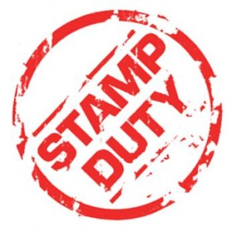
- What is stamp duty?

- Draw a graph to represent Stamp Duty.

  - 3% of the market value up to $45,000
  - 5% on the value over $45,000.

$2 000
$1 000
 |  |  | $10 000 |  | $20 000 |  | $30 000 |  | $40 000  Value |  | $50 000 |  | $60 000 |  | $70 000

  - What is the stamp duty for a car valued at $10 000. $ ______

  - What is the stamp duty for a car valued at $70 000. $ ______

  - What is the stamp duty for a car valued at $50 000. $ ______

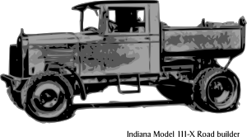
- Stamp Duty

  - 3% of the market value up to $45,000
  - 5% on the value over $45,000.

  - What is the stamp duty for a car valued at $10 000.

Stamp Duty = 0.03 x $ ________

$ ______

  - What is the stamp duty for a car valued at $70 000.

Stamp Duty = 0.03 x $ _________ + 0.05 x ( $________ - $ 45 000)

$ ______

  - What is the stamp duty for a car valued at $50 000.

Stamp Duty =

$ ______

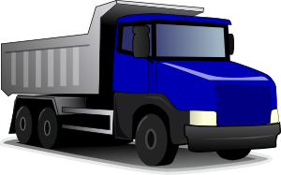
  - What is the stamp duty for a truck valued at $150 000.

Stamp Duty =

$ ______

  - What is the stamp duty for a Ferrari valued at $450 000.

Stamp Duty =

$ ______
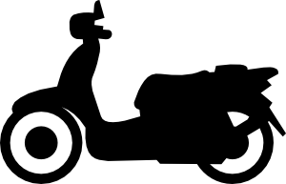
  - What is the stamp duty for a motor scooter valued at $2 800.

Stamp Duty =

$ ______

